**Background**

I play a computer game called DotA. It's a team game, played 5 vs. 5. Each player chooses a "hero" from a list of 113 heroes, each of which is unique, and then the two teams play against each other.

Choosing and playing heroes is very complex, so I wanted to make a tool that tracked three things for each hero:

* General notes
* Tips for gameplay, itemization, etc.
* Relationships - synergies with other heroes for choosing allies, and counters to other heroes

That way I can develop a database of certain knowledge that is hard to remember during the brief hero selection phase.

**The Tool**- <https://github.com/dipique/dotadb>

Aside from basic object CRUD functionality, the tool consists of pretty much one page. It lets you select heroes as either allies or enemies; those heroes then display with their notes, tips, and relationships to inform remaining picks and gameplay.

The overall layout is pretty basic:

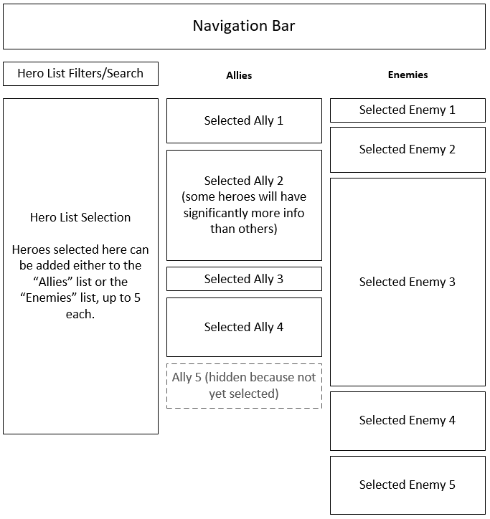

You select heroes on the left, and a box with all their associated info get added to the lists on the right.

**Why I need help with such a simple project**

I need help designing the hero detail boxes, e.g. "Selected Ally 1". The information needs to be compact but readable.

Each of the hero detail boxes is loaded as partial view, so I only need one hero detail box designed. Each one needs to contain the following:

* A hero icon (120x68, but could be displayed as 60x34 to conserve real estate I think)
* The hero name
* Hero notes (multi-line text)
* Tips (multiple)
  + Type/Category (e.g. "Ability Use" or "Itemization")
  + Text (multi-line text)
* Relationships (multiple)
  + Hero Name (of the hero with which the selected hero has the relationship)
  + Type/Category (e.g. "Synergy" or "Counter")
  + Text (multi-line text)

The width can be up to 450px. The height is flexible, but the more information that shows on-screen at once, the better.

Here's a screenshot of just the [hero selection screen](https://github.com/dipique/dotadb/blob/master/DotAPicker/Views/Home/DotAPicker.cshtml):

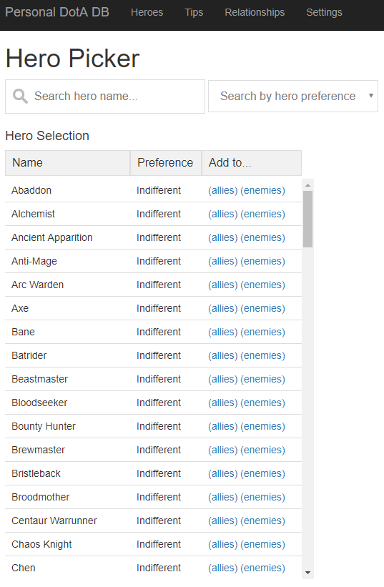

**Wrapping it up...**

And that's what I need help with: the HTML (with or without CSS) for a partial view that can contain the information listed above.